Calculation

One Node
- w*x + b = (1)*(2) + (-1)*(1) + (1)*(3) + (-5) = -1
- ReLU: -1 → 0 because -1 is negative.
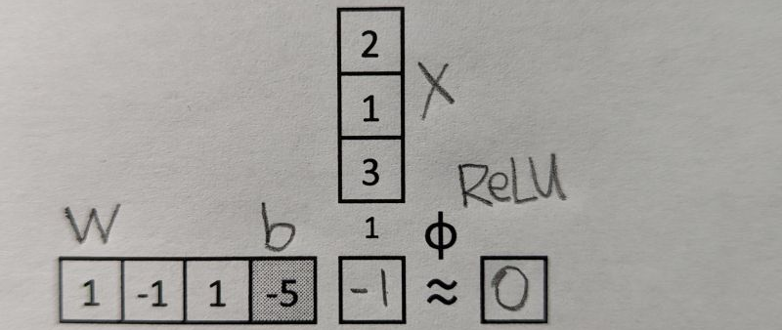

Four Nodes
- Multiply the same input x with each neuron’s weights plus a bias term in each row
w1 * x + b1 = 2 - 1 + 3 - 5 = -1
w2 * x + b2 = 2 + 1 = 3
w3 * x + b3 = 1 + 3 + 1 = 5
w4 * x + b4 = 2 + 3 - 2 = 3
- ReLU: negative values → 0; positive values → same values
- Count the parameters of each node: 3 + 1
- Count all the parameters of this network: 4 * (3 + 1) = 16
- Draw a graphical representation of this network
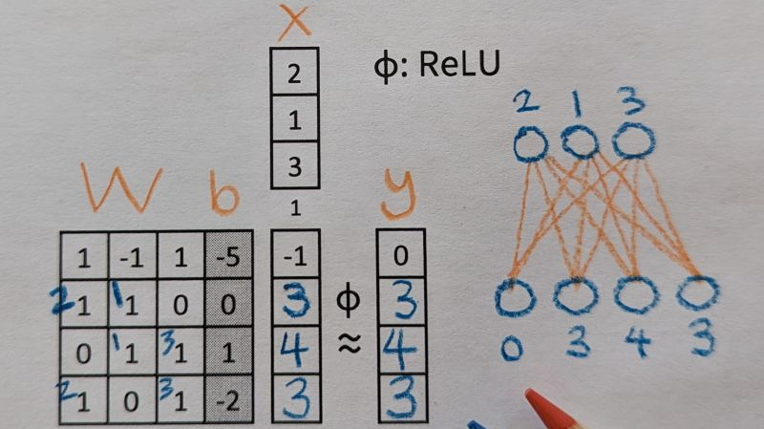

Hidden Layer
- Hidden Layer: W1*x + b1 → ReLU → h
- Output Layer: W2*h + b2→ ReLU → y
- Draw a graphical representation of this two-layer network
- See the correspondence between weights and nodes
# of weights in a hidden node = # of nodes in the input layer
# of weights in an output node = # of nodes in the hidden layer
- Count all the parameters of this network: 4 * (3 + 1) + 2 * (4 + 1) = 16 + 10 = 26
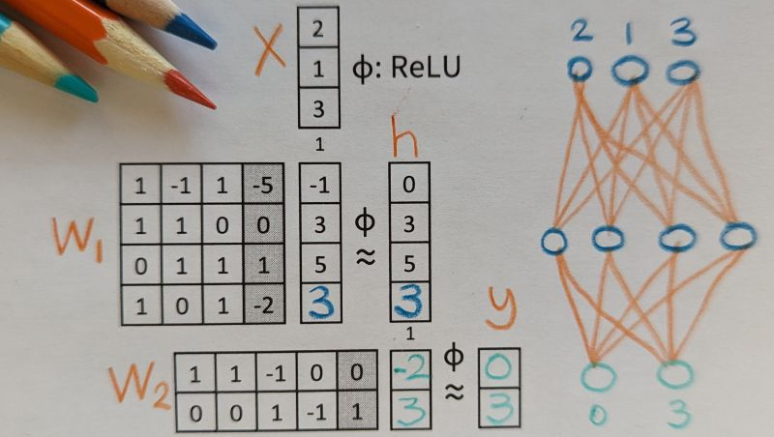

Three Inputs
- Inputs: The network takes a batch of three input vectors (x1, x2, x3), each corresponds to a column in the top-most matrix.
- Shade each corresponding pair of weight vector (row) and feature vector (column) using a unique color
- Calculate each missing value by taking the dot product between corresponding weight vector and feature vector
- See that the same set of weights are applied to each input, x1, x2, x3
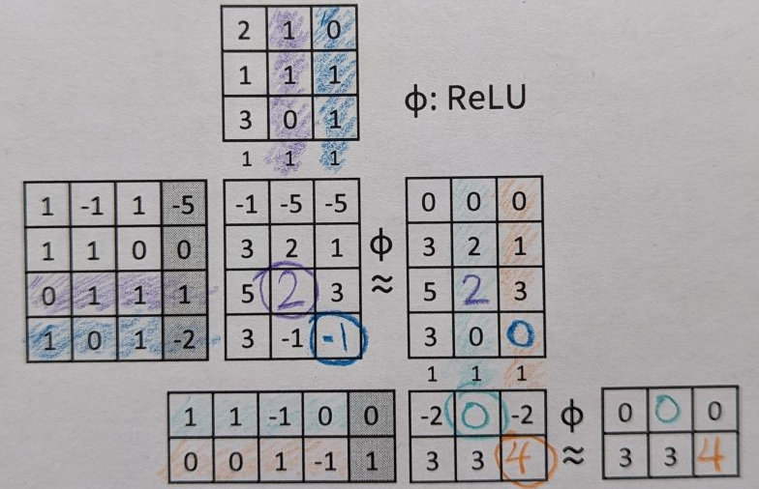

Seven Layers
- Inputs: The network takes a batch of two input vectors (x1, x2)
- Layers: The network has seven layers.
- Draw links between two layers of nodes
- Shade corresponding weights (left) and links (right) in matching colors
- Apply ReLU to "deactivate" negative values to 0 (except for the output layer).
- Calculate one missing value in each layer
Layer 1: 0 x 3 + 1 x 4 + 1 x 5 = 9
Layer 2: 0 x 5 + 0 x 4 + 1 x 3 + 1 x 7 + (-1) x 9 = 1
Layer 3: 1 x 6 + 2 x 1 = 8
Layer 4: 0 x 7 + (-1) x 5 + 1 x 8 = 3
Layer 5: 1 x 2 + 0 x 3 = 2
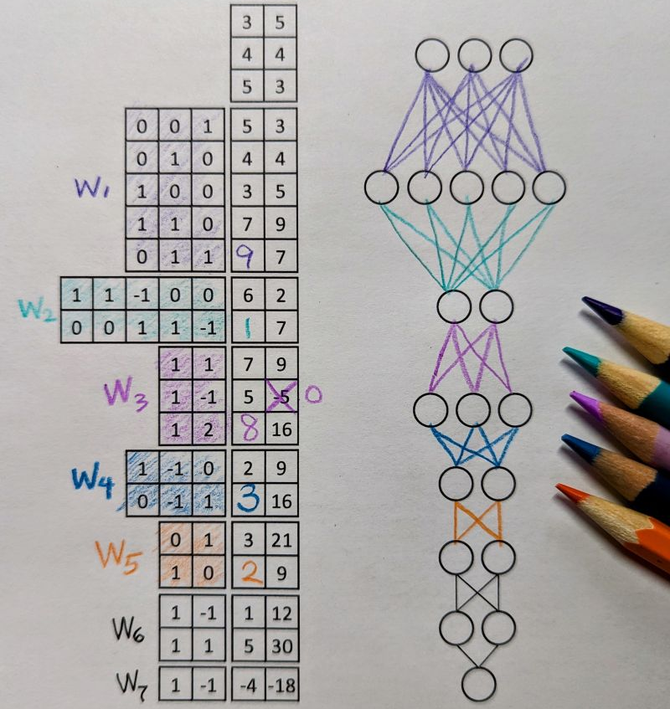

Mixture of Experts
- [Inputs] The MoE block received two tokens (blue, orange).
- Gate Network processed X1 (blue) and determined Expert 2 should be activated.
- Expert 2 processed X1 (blue).
- Gate Network processed X2 (orange) and determined Expert 1 should be activated.
- Expert 1 processed X2 (orange).
- ReLU activation function processed the outputs of the experts and produced the final output.
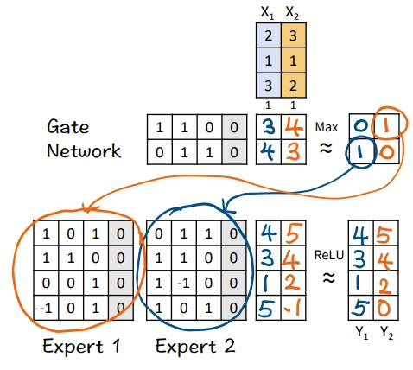

Recurrent Neural Network
- Hidden state are initialized to [0, 0].
- The first input 𝘹1 and hidden states [0, 0] are linearly combined using weights 𝘈 and 𝘉, followed by a non-linear activation function ReLu, to calculate the new hidden states -> [3, 6].
- Hidden states [3, 6] are linearly combined using weights 𝘊 to obtain the first output 𝘺1
- Repeat 1-3 for 𝘹2, 𝘹3, 𝘹4
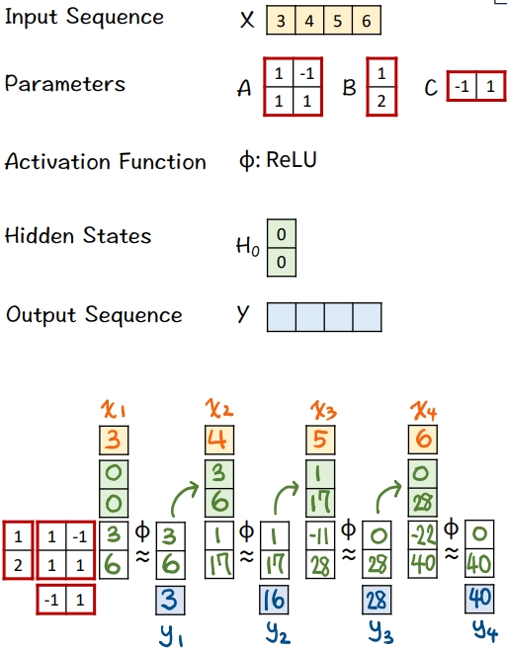

Mamba's S6 Model
- Left: All four tokens in the input sequence are processed by a linear layer to calculate a set of weights.
- Right: These weights are used to drive an RNN-like network.
- The first input [3] and hidden states [0, 0] are linearly combined using weights B=[-1; 2] and A=[1, 0; 0, -1] to calculate new hidden states -> [-3, 6]. Note that NO non-linear activation function is involved.
- Hidden states [-3, 6] are linearly combined using weights C = [-2, -3] to obtain the first output [-12]
- Repeats steps 3 and 4 using different sets of weights A, B, C.
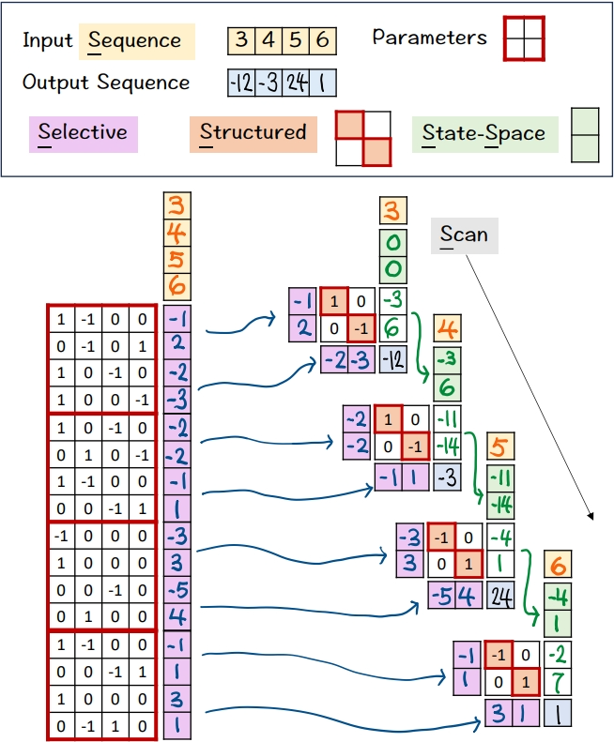

Matrix Multiplication
𝗗𝗶𝗺𝗲𝗻𝘀𝗶𝗼𝗻𝘀: We can easily see C's dimensions must match A's height (vertical) and B's width (horizontal).
𝗦𝗰𝗮𝗹𝗮𝗯𝗹𝗲: If we scale any of the matrices A, B, C to an arbitrary size, we can easily see how the sizes of other matrices must change accordingly to match the dimensions.
𝗥𝗼𝘄 𝘃𝘀. 𝗖𝗼𝗹𝘂𝗺𝗻 𝗩𝗲𝗰𝘁𝗼𝗿𝘀: For each value in C, we can easily see the corresponding row vector (green) and column vector (yellow) that are combined using dot-product to obtain the value.
𝗦𝘁𝗮𝗰𝗸𝗮𝗯𝗹𝗲: Because of their compactness, we can stack multiple grids like these to represent the underlying sequence of matrix multiplications of a deep neural network (e.g., multi-layer perceptron), like the one I shared a while ago.
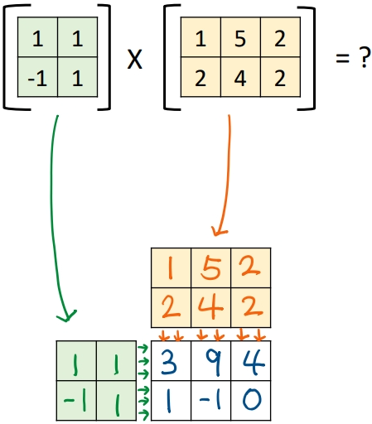

Large Language Model
- Given a sequence of input embeddings, represented as yellow column vectors.
- Feed the input embeddings to the LLM.
- The LLM predicts the probability distribution of the next output word over a vocabulary of 10 words, which is represented as a column vector shaded in blue. Then, we calculate the cumulative distribution by hand and write the results in blue. To do so, we start with zero at the bottom, add the number in each cell as we go up, until we reach 100 at the top. Note that for a valid probability distribution, they should add up to 100 (percentage).
- Draw the next random number (.65) and lookup the range in the cumulative distribution in which this random number falls (.45 < .65 < .95).
- Lookup the corresponding word (how) and fill that word in the first blank.
- Repeat step 3 for the next output word.
- Draw the next random number (.92) and lookup the range in the cumulative distribution in which this random number falls (.57 < .92 < .97).
- Lookup the corresponding word (are) and fill that word in the second blank.
- Repeat step 3 for the next output word
- Draw the next random number (.52) and lookup the range in the cumulative distribution in which this random number falls (.47 < .52 < .97).
- Lookup the corresponding word (you) and fill that word in the third blank.
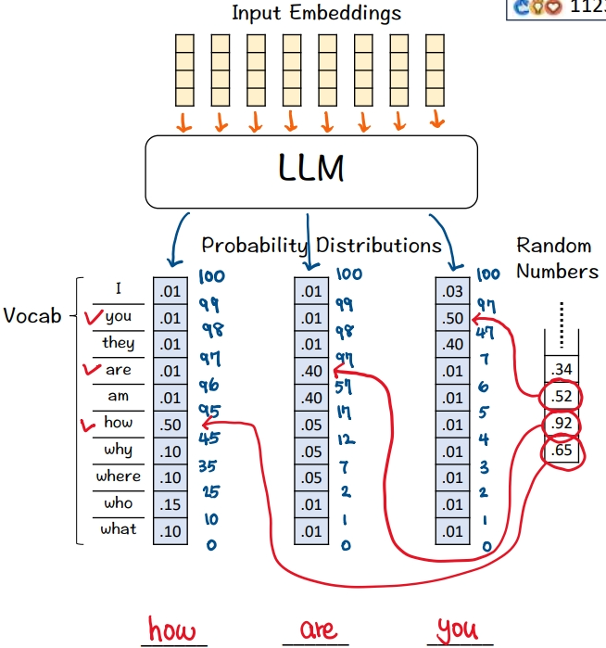

Multi Layer Perceptron
- Given a code template (left), implement the multi layer perception as depicted (right).
- 𝗙𝗶𝗿𝘀𝘁 𝗹𝗶𝗻𝗲𝗮𝗿 𝗹𝗮𝘆𝗲𝗿. The size of input features is 3. The size of output features is 4. We can see the size of the weight matrix is 4 by 3. Also, there is an extra column for the biases (bias = T).
- The activation function is ReLU. We can see the effect of ReLU on the first feature (-1 -> 0).
- 𝗦𝗲𝗰𝗼𝗻𝗱 𝗹𝗶𝗻𝗲𝗮𝗿 𝗹𝗮𝘆𝗲𝗿. The size of input features is 4, which is the same as the size of output features from the previous layer. The size of output features is 2. We can see the size of the weight matrix is 2 by 4. But, there isn't an extra column for the biases (bias = F).
- The activation function is ReLU.
- 𝗙𝗶𝗻𝗮𝗹 𝗹𝗶𝗻𝗲𝗮𝗿 𝗹𝗮𝘆𝗲𝗿. The size of input features is 2, which is the same as the size of output features from the previous layer. The size of output features is 5. We can see the size of the weight matrix is 5 by 2. Also, there is an extra column for the biases (bias = T).
- The activation function is Sigmoid. We can see the effect of Sigmoid, which is a non-linear mapping from raw scores (3, 0, -2, 5, -5) to probability values between 0 and 1.
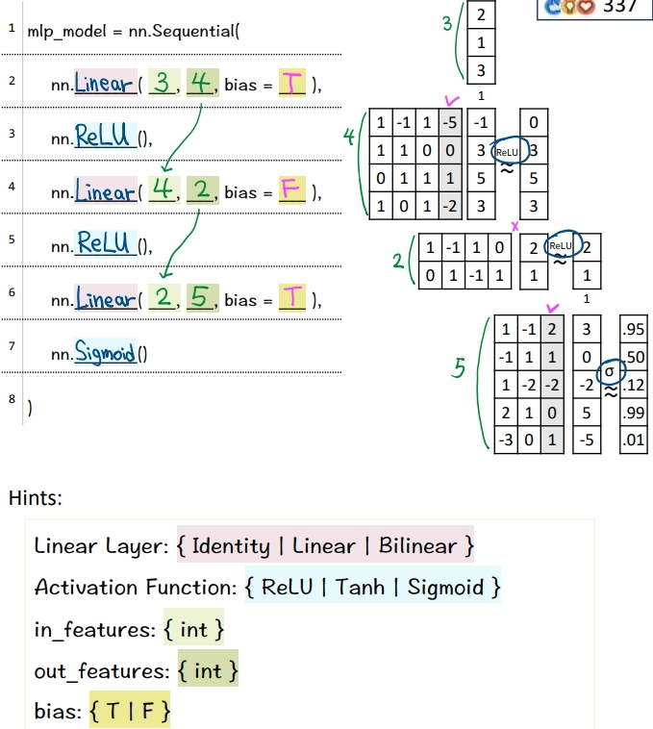

Backprogagation
- 𝗙𝗼𝗿𝘄𝗮𝗿𝗱 𝗣𝗮𝘀𝘀: Given a multi layer perceptron (3 levels), an input vector X, predictions Y^{Pred} = [0.5, 0.5, 0], and ground truth label Y^{Target} = [0, 1, 0].
- 𝗕𝗮𝗰𝗸𝗽𝗿𝗼𝗽𝗮𝗴𝗮𝘁𝗶𝗼𝗻: Insert cells to hold our calculations.
- 𝗟𝗮𝘆𝗲𝗿 𝟯 - 𝗦𝗼𝗳𝘁𝗺𝗮𝘅 (blue): Calculate ∂L / ∂z3 directly using the simple equation: Y^{Pred} - Y^{Target} = [0.5, -0.5, 0]. This simple equation is the benefit of using Softmax and Cross Entropy Loss together.
- 𝗟𝗮𝘆𝗲𝗿 𝟯 - 𝗪𝗲𝗶𝗴𝗵𝘁𝘀 (orange) & 𝗕𝗶𝗮𝘀𝗲𝘀 (black): Calculate ∂L / ∂W3 and ∂L / ∂b3 by multiplying ∂L / ∂z3 and [ a2 | 1 ].
- 𝗟𝗮𝘆𝗲𝗿 𝟮 - 𝗔𝗰𝘁𝗶𝘃𝗮𝘁𝗶𝗼𝗻𝘀 (green): Calculate ∂L / ∂a2 by multiplying ∂L / ∂z3 and W3.
- 𝗟𝗮𝘆𝗲𝗿 𝟮 - 𝗥𝗲𝗟𝗨 (blue): Calculate ∂L / ∂z2 by multiplying ∂L / ∂a2 with 1 for positive values and 0 otherwise.
- 𝗟𝗮𝘆𝗲𝗿 𝟮 - 𝗪𝗲𝗶𝗴𝗵𝘁𝘀 (orange) & 𝗕𝗶𝗮𝘀𝗲𝘀 (black): Calculate ∂L / ∂W2 and ∂L / ∂b2 by multiplying ∂L / ∂z2 and [ a1 | 1 ].
- 𝗟𝗮𝘆𝗲𝗿 𝟭 - 𝗔𝗰𝘁𝗶𝘃𝗮𝘁𝗶𝗼𝗻𝘀 (green): Calculate ∂L / ∂a1 by multiplying ∂L / ∂z2 and W2.
- 𝗟𝗮𝘆𝗲𝗿 𝟭 - 𝗥𝗲𝗟𝗨 (blue): Calculate ∂L / ∂z1 by multiplying ∂L / ∂a1 with 1 for positive values and 0 otherwise.
- 𝗟𝗮𝘆𝗲𝗿 𝟭 - 𝗪𝗲𝗶𝗴𝗵𝘁𝘀 (orange) & 𝗕𝗶𝗮𝘀𝗲𝘀 (black): Calculate ∂L / ∂W1 and ∂L / ∂b1 by multiplying ∂L / ∂z1 and [ x | 1 ].
- 𝗚𝗿𝗮𝗱𝗶𝗲𝗻𝘁 𝗗𝗲𝘀𝗰𝗲𝗻𝘁: Update weights and biases (typically a learning rate is applied here).
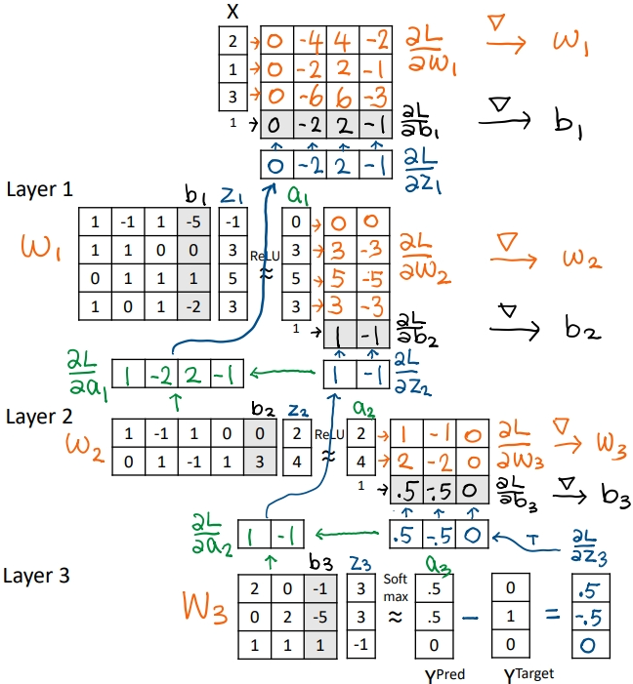

Transformer
- Given
- Input features from the previous block (5 positions)
- Attention
- Feed all 5 features to a query-key attention module (QK) to obtain an attention weight matrix (A). I will skip the details of this module. In a follow-up post I will unpack this module.
- Attention Weighting
- Multiply the input features with the attention weight matrix to obtain attention weighted features (Z). Note that there are still 5 positions.
- The effect is to combine features a͟c͟r͟o͟s͟s͟ ͟p͟o͟s͟i͟t͟i͟o͟n͟s͟ (horizontally), in this case, X1 := X1 + X2, X2 := X2 + X3....etc.
- FFN: First Layer
- Feed all 5 attention weighted features into the first layer.
- Multiply these features with the weights and biases.
- The effect is to combine features a͟c͟r͟o͟s͟s͟ ͟f͟e͟a͟t͟u͟r͟e͟ ͟d͟i͟m͟e͟n͟s͟i͟o͟n͟s͟ (vertically).
- The dimensionality of each feature is increased from 3 to 4.
- Note that each position is processed by the same weight matrix. This is what the term "position-wise" is referring to.
- Note that the FFN is essentially a multi layer perceptron.
- ReLU
- Negative values are set to zeros by ReLU.
- FFN: Second Layer
- Feed all 5 features (d=3) into the second layer.
- The dimensionality of each feature is decreased from 4 back to 3.
- The output is fed to the next block to repeat this process.
- Note that the next block would have a completely separate set of parameters.
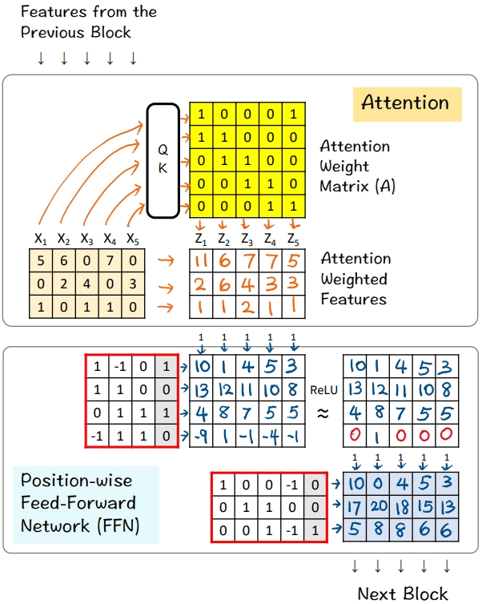

Batch Normalisation
- Given
- A mini-batch of 4 training examples, each has 3 features.
- Linear Layer
- Multiply with the weights and biases to obtain new features
- ReLU
- Apply the ReLU activation function, which has the effect of suppressing negative values. In this exercise, -2 is set to 0.
- Batch Statistics
- Compute the sum, mean, variance, and standard deviation across the four examples in this min-batch.
- Note that these statistics are computed for each row (i.e., each feature dimension).
- Shift to Mean = 0
- Subtract the mean (green) from the activation values for each training example
- The intended effect is for the 4 activation values in each dimension to average to zero
- Scale to Variance = 1
- Divide by the standard deviation (orange)
- The intended effect is for the 4 activation values to have variance equal to one.
- Scale & Shift
- Multiply the normalized features from [6] by a linear transformation matrix, and pass the results to the next layer
- The intended effect is to scale and shift the normalized feature values to a new mean and variance, which are to be learned by the network
- The elements in the diagonal and the last column are trainable parameters the network will learn.
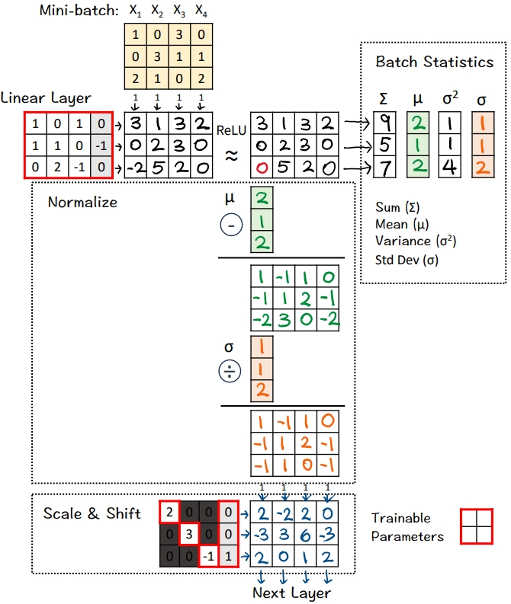

Generative Adversarial Network (GAN)
- Given
- 4 noise vectors in 2D (N)
- 4 real data vectors in 4D (X)
- 🟩 Generator: First Layer
- Multiply the noise vectors with weights and biases to obtain new feature vectors
- 🟩 Generator: ReLU
- Apply the ReLU activation function, which has the effect of suppressing negative values. In this exercise, -1 and -2 are crossed out and set to 0.
- 🟩 Generator: Second Layer
- Multiply the features with weights and biases to obtain new feature vectors.
- ReLU is applied. But since every value is positive, there's no effect.
- These new feature vectors are the "Fake" data (F) generated by this simple 2-layer Generator network.
- 🟦 Discriminator: First Layer
- Feed both Fake data (F) and real data (X) to the first linear layer
- Multiply F and X with weights and biases to obtain new feature vectors.
- ReLU is applied. But since every value is positive, there's no effect.
- 🟦 Discriminator: Second Layer
- Multiply the features with one set of weights and bias to obtain new features.
- The intended effect is to reduce to just one feature value per data vector.
- 🟦 Discriminator: Sigmoid σ
- Convert features (Z) to probability values (Y) using the Sigmoid function
- 1 means the Discriminator is 100% confident the data is real.
- 0 means the Discriminator is 100% confident the data is fake.
- 🏋️ Training: 🟦 Discriminator
- Compute the loss gradients of the Discriminator by the simple equation of Y - YD. Why so simple? Because when we use sigmoid and binary entropy loss together, the math magically simplifies to this equation.
- YD are the target predictions from the Discriminator's perspective. The Discriminator must learn to predict 0 for the four Fake data (F) and 1 for the four Real data (X). YD=[0,0,0,0,1,1,1,1].
- Note that the Discriminator's loss involves both the Fake data and Real data.
- With the loss gradients computed, we can kickoff the back propagation process to update the Discriminator's weights and biases (blue borders).
- 🏋️ Training: 🟩 Generator
- Compute the loss gradients of the Generator by the simple equation of Y - YG.
- YG are the target predictions from the Generator's perspective. The Generator must fool the Discriminator into predicting 1 for the four Fake data (F). YG=[1,1,1,1].
- Note that the Generator's loss involves only the Fake data.
- With the loss gradients computed, we can kickoff the back propagation process to update the Generator's weights and biases (green borders).
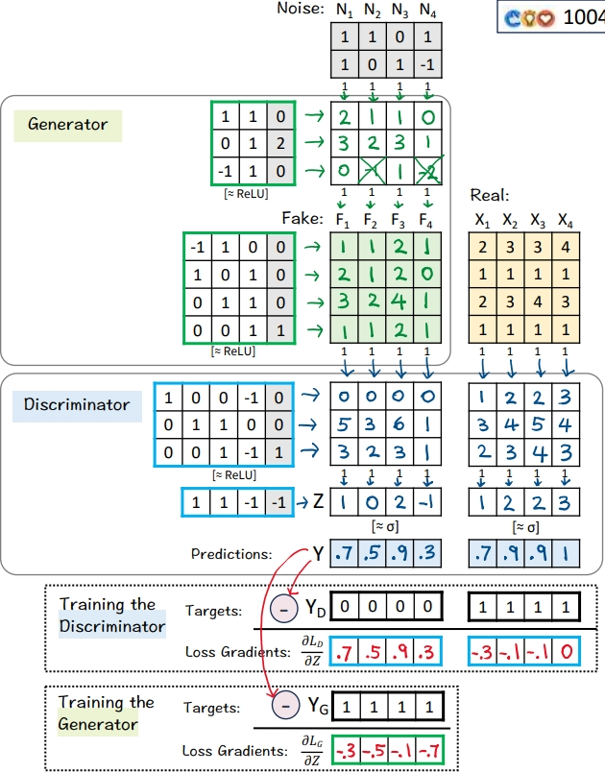

Self Attention
- Given
- A set of 4 feature vectors (6-D)
- Query, Key, Value
- Multiply features x's with linear transformation matrices WQ, WK, and WV, to obtain query vectors (q1,q2,q3,q4), key vectors (k1,k2,k3,k4), and value vectors (v1,v2,v3,v4).
- "Self" refers to the fact that both queries and keys are derived from the same set of features.
- 🟪 Prepare for MatMul
- Copy query vectors
- Copy the transpose of key vectors
- 🟪 MatMul
- Multiply K^T and Q
- This is equivalent to taking dot product between every pair of query and key vectors.
- The purpose is to use dot product as an estimate of the "matching score" between every key-value pair.
- This estimate makes sense because dot product is the numerator of Cosine Similarity between two vectors.
- 🟨 Scale
- Scale each element by the square root of dk, which is the dimension of key vectors (dk=3).
- The purpose is to normalize the impact of the dk on matching scores, even if we scale dk to 32, 64, or 128.
- To simplify hand calculation, we approximate [ □/sqrt(3) ] with [ floor(□/2) ].
- 🟩 Softmax: e^x
- Raise e to the power of the number in each cell
- To simplify hand calculation, we approximate e^□ with 3^□.
- 🟩 Softmax: ∑
- Sum across each column
- 🟩 Softmax: 1 / sum
- For each column, divide each element by the column sum
- The purpose is normalize each column so that the numbers sum to 1. In other words, each column is a probability distribution of attention, and we have four of them.
- The result is the Attention Weight Matrix (A) (yellow)
- 🟦 MatMul
- Multiply the value vectors (Vs) with the Attention Weight Matrix (A)
- The results are the attention weighted features Zs.
- They are fed to the position-wise feed forward network in the next layer.

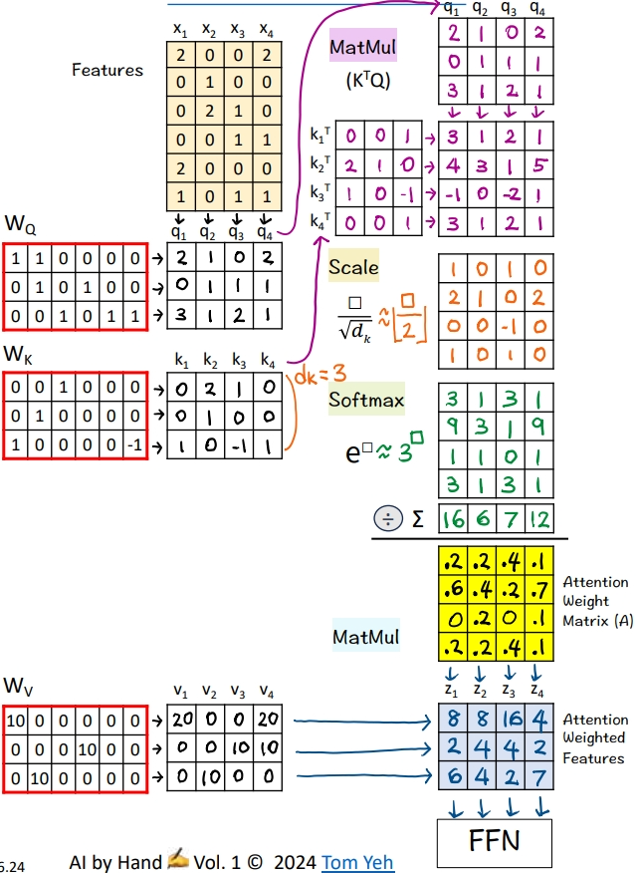

Dropout
- Given
- A training set of 2 examples X1, X2
- 🟧 Random: p > 0.5
- Draw 4 random numbers
- For each random number, if it is above 0.5, we keep and denote it as ◯. Otherwise we drop and denote it as ╳.
- The result is [◯, ╳, ◯, ╳]
- 🟧 Dropout: Matrix
- Calculate the scaling factor: 1 / (1-p) = 2
- Set the diagonal based on [◯, ╳, ◯, ╳], where ◯ = 2 and ╳ = 0
- The purpose is to drop the 2nd and the 4th nodes, and scale the remaining two nodes by 2.
- 🟦 Random: p > 0.33
- Draw 3 random numbers
- For each random number, if it is above 0.33, we keep and denote it as ◯. Otherwise we drop and denote it as ╳.
- The result is [◯, ◯, ╳]
- 🟦 Dropout: Matrix
- Calculate the scaling factor: 1 / (1-p) = 1.5
- Set the diagonal based on [◯, ◯, ╳], where ◯ = 1.5 and ╳ = 0
- The purpose is to drop the 3rd node, and scale the remaining two nodes by 1.5.
- Feed Forward
- Now we have all the matrices ready across the layers, perform the feed forward pass by calculating a series of matrix multiplications from the top to the bottom
- ReLU activation function is applied along the way to set negative feature values to zeroes, denoted by ╳.
- The outputs are Y.
- 🟥 Loss Gradients of Mean Square Error (MSE)
- The formula is 2 * (Y - Y')
- First we calculate Outputs (Y) - Targets (Y')
- Second we multiply each element by 2
- Update Weights
- Use loss gradients to start back propagation
- Update some weights (light red)
- The values of the new weights are for demonstration purpose only, not based on real calculation.

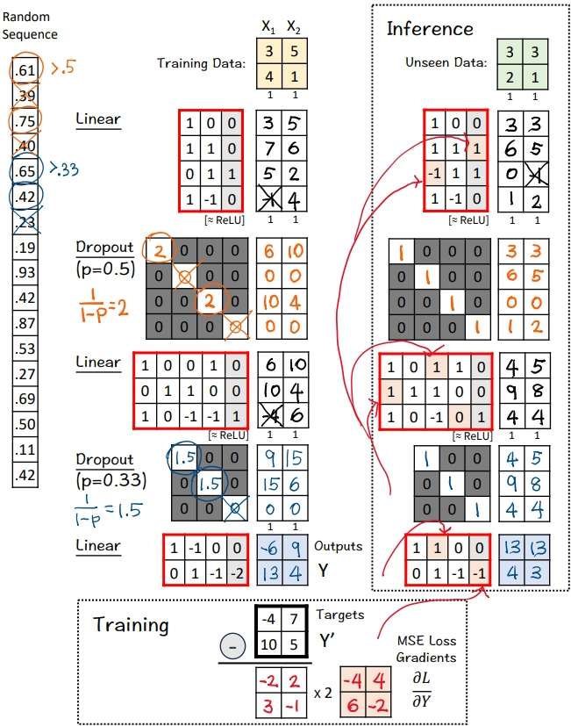

Autoencoder
- Given
- Four training examples X1, X2, X3, X4
- Auto
- Copy training examples to Targets (Y')
- The purpose is to train the network to reconstruct the training examples.
- Since each target is a training example itself, we use the Greek word "auto" which means "self." This crucial step is what makes an autoencoder "auto."
- 🟨 Encoder: Layer 1 + ReLU
- Multiply inputs with weights and biases
- Apply ReLU, crossing out negative values (-1 -> 0)
- 🟨 Encoder: Layer 2 + ReLU
- Multiply features with weights and biases
- Apply ReLU, crossing out negative values (-1 -> 0)
- This layer is often called the "bottleneck" because its outputs (green 🟩) have a lot fewer feature dimensions (2) than the input features (4).
- 🟦 Decoder: Layer 1 + ReLU
- Multiply features with weights and biases
- Apply ReLU, crossing out negative values. Here, no negative values to cross out.
- 🟦 Decoder: Layer 2
- Multiply features with weights and biases
- The Outputs (Y) are the Decoder's attempt to reconstruct the training examples from their reduced 2-D representation (green 🟩).
- 🟥 Loss Gradients & Backpropagation
- Calculate the gradients of the Mean Square Error (MSE) loss between the outputs (Y) and targets (Y').
- The formula is 2 * (Y - Y')
- First we calculate Outputs (Y) - Targets (Y')
- Second we multiply each element by 2
- These gradients kick off the backpropagation process to update weights and biases.
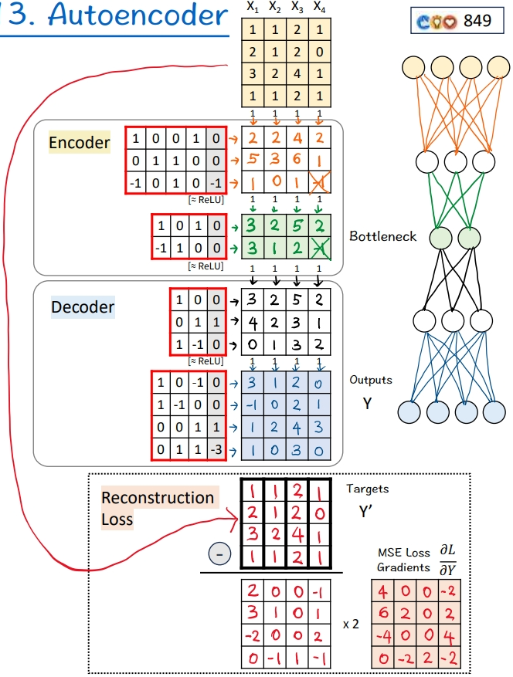

Vector Database
- Given
- A dataset of three sentences, each has 3 words (or tokens)
- In practice, a dataset may contain millions or billions of sentences. The max number of tokens may be tens of thousands (e.g., 32,768 mistral-7b).
Process "how are you"
- 🟨 Word Embeddings
- For each word, look up corresponding word embedding vector from a table of 22 vectors, where 22 is the vocabulary size.
- In practice, the vocabulary size can be tens of thousands. The word embedding dimensions are in the thousands (e.g., 1024, 4096)
- 🟩 Encoding
- Feed the sequence of word embeddings to an encoder to obtain a sequence of feature vectors, one per word.
- Here, the encoder is a simple one layer perceptron (linear layer + ReLU)
- In practice, the encoder is a transformer or one of its many variants.
- 🟩 Mean Pooling
- Merge the sequence of feature vectors into a single vector using "mean pooling" which is to average across the columns.
- The result is a single vector. We often call it "text embeddings" or "sentence embeddings."
- Other pooling techniques are possible, such as CLS. But mean pooling is the most common.
- 🟦 Indexing
- Reduce the dimensions of the text embedding vector by a projection matrix. The reduction rate is 50% (4->2).
- In practice, the values in this projection matrix is much more random.
- The purpose is similar to that of hashing, which is to obtain a short representation to allow faster comparison and retrieval.
- The resulting dimension-reduced index vector is saved in the vector storage.
- Process "who are you"
- Repeat [2]-[5]
- Process "who am I"
- Repeat [2]-[5]
Now we have indexed our dataset in the vector database.
- 🟥 Query: "am I you"
- Repeat [2]-[5]
- The result is a 2-d query vector.
- 🟥 Dot Products
- Take dot product between the query vector and database vectors. They are all 2-d.
- The purpose is to use dot product to estimate similarity.
- By transposing the query vector, this step becomes a matrix multiplication.
- 🟥 Nearest Neighbor
- Find the largest dot product by linear scan.
- The sentence with the highest dot product is "who am I"
- In practice, because scanning billions of vectors is slow, we use an Approximate Nearest Neighbor (ANN) algorithm like the Hierarchical Navigable Small Worlds (HNSW).
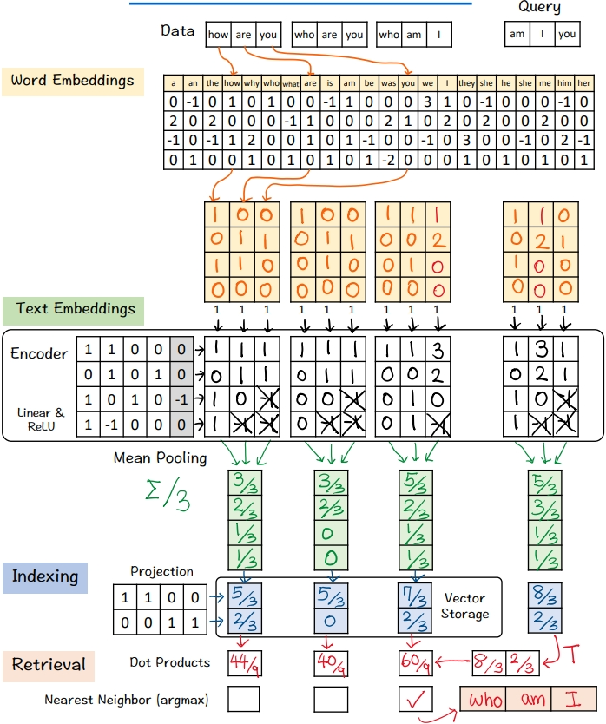

Contrastive Language–Image Pre-training
- Given
- A mini batch of 3 text-image pairs
- OpenAI used 400 million text-image pairs to train its original CLIP model.
Process 1st pair: "big table"

- 🟪 Text → 2 Vectors (3D)
- Look up word embedding vectors using word2vec.
- 🟩 Image → 2 Vectors (4D)
- Divide the image into two patches.
- Flatten each patch
- Process other pairs
- Repeat [2]-[3]
- 🟪 Text Encoder & 🟩 Image Encoder
- Encode input vectors into feature vectors
- Here, both encoders are simple one layer perceptron (linear + ReLU)
- In practice, the encoders are usually transformer models.
- 🟪 🟩 Mean Pooling: 2 → 1 vector
- Average 2 feature vectors into a single vector by averaging across the columns
- The goal is to have one vector to represent each image or text
- 🟪 🟩 -> 🟨 Projection
- Note that the text and image feature vectors from the encoders have different dimensions (3D vs. 4D).
- Use a linear layer to project image and text vectors to a 2D shared embedding space.
Contrastive Pre-training 🏋️

- Prepare for MatMul
- Copy text vectors (T1,T2,T3)
- Copy the transpose of image vectors (I1,I2,I3)
- They are all in the 2D shared embedding space.
- 🟦 MatMul
- Multiply T and I matrices.
- This is equivalent to taking dot product between every pair of image and text vectors.
- The purpose is to use dot product to estimate the similarity between a pair of image-text.
- 🟦 Softmax: e^x
- Raise e to the power of the number in each cell
- To simplify hand calculation, we approximate e^□ with 3^□.
- 🟦 Softmax: ∑
- Sum each row for 🟩 image→🟪 text
- Sum each column for 🟪 text→ 🟩 image
- 🟦 Softmax: 1 / sum
- Divide each element by the column sum to obtain a similarity matrix for 🟪 text→🟩 image
- Divide each element by the row sum to obtain a similarity matrix for 🟩 image→🟪 text
- 🟥 Loss Gradients
- The "Targets" for the similarity matrices are Identity Matrices.
- Why? If I and T come from the same pair (i=j), we want the highest value, which is 1, and 0 otherwise.
- Apply the simple equation of [Similarity - Target] to compute gradients of for both directions.
- Why so simple? Because when Softmax and Cross-Entropy Loss are used together, the math magically works out that way.
- These gradients kick off the backpropagation process to update weights and biases of the encoders and projection layers (red borders).
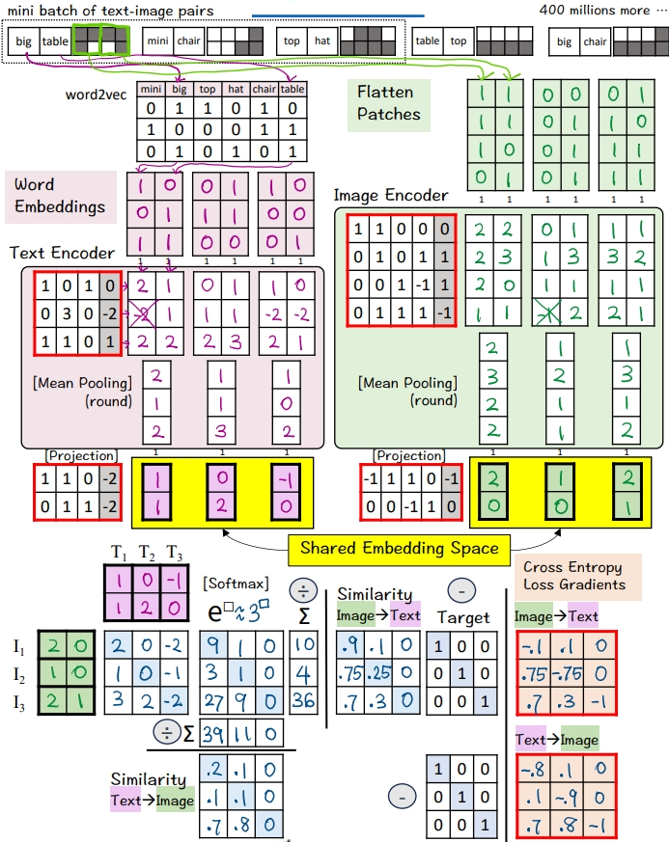

Residual Network
R͟e͟s͟i͟d͟u͟a͟l͟ ͟B͟l͟o͟c͟k͟

- Given
- A mini batch of 3 input vectors (3D)
- Linear Layer
- Multiply the input with weights and bias
- Apply ReLU (negatives → 0)
- Obtain 3 feature vectors
- Concatenate
- Stack (horizontally) an identity matrix and the weight and bias matrix of the 2nd layer
- Stack (vertically) the input vectors and the feature vectors from the previous layer
- Draw lines to visualize the links between rows (weights) and columns (features)
- These links are the "Skip Connections"
- Linear Layer + Identity
- Multiply the two stacked matrices
- This is equivalent to F(X) + X
- Apply ReLU (negatives → 0)
- Pass the results to the next residual block
T͟r͟a͟n͟s͟f͟o͟r͟m͟e͟r͟'͟s͟ ͟E͟n͟c͟o͟d͟e͟r͟ ͟B͟l͟o͟c͟k͟
Let's see how residual block (aka. skip connections) work in a transformer model

- 🟩 Attention
- A sequence of 3 input vectors (2D)
- Compute an attention matrix (bright yellow)
- Multiply the input vectors with the attention matrix to obtain attention-weighted vectors.
- 🟩 Concatenate
- Stack two identity matrices (to achieve 1 + 1)
- Stack the input vectors and the attention-weighted vectors
- Draw skip connections
- 🟩 Add
- Multiply the two stacked matrices
- 🟪 Feed Forward: First Layer
- Multiply the input with weights and bias
- Apply ReLU (negatives → 0)
- Obtain 3 feature vectors
- 🟪 Feed Forward: Concatenate
- Stack and visualize like step [3]
- 🟪 Feed Forward: Second Layer + Identity
- Multiply the two stacked matrices
- Apply ReLU (negatives → 0)
- Pass the results to the next encoder block
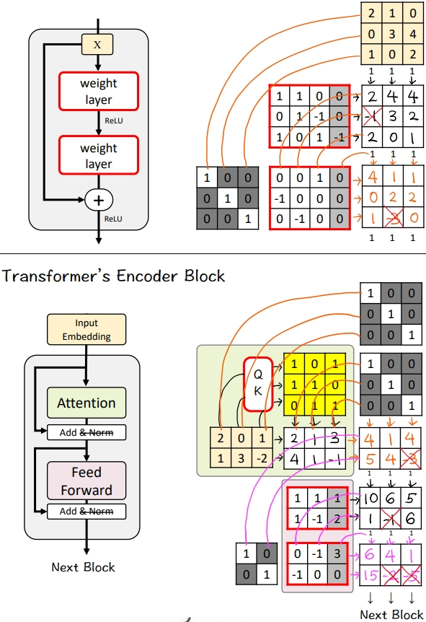

Graph Convolutional Network
- Given
- A graph with five nodes A, B, C, D, E
- 🟩 Adjacency Matrix: Neighbors
- Add 1 for each edge to neighbors
- Repeat in both directions (e.g., A->C, C->A)
- Repeat for both GCN layers
- 🟩 Adjacency Matrix: Self
- Add 1's for each self loop
- Equivalent to adding the identity matrix
- Repeat for both GCN layers
- 🟪 GCN1: Messages
- Multiply the node embeddings 🟨 with weights and biases
- Apply ReLU (negatives → 0)
- The result is one message per node
- 🟪 GCN1: Pooling
- Multiply the messages with the adjacent matrix
- The purpose is the pool messages from each node's neighbors as well as from the node itself.
- The result is a new feature per node
- 🟪 GCN1: Visualize
- For node 1, visualize how messages are pooled to obtain a new feature for better understanding
- [3,0,1] + [1,0,0] = [4,0,1]
- 🟪 GCN2: Messages
- Multiply the node features with weights and biases
- Apply ReLU (negatives → 0)
- The result is one message per node
- 🟪 GCN2: Pooling
- Multiply the messages with the adjacent matrix
- The result is a new feature per node
- 🟪 GCN2: Visualize
- For node 3, visualize how messages are pooled to obtain a new feature for better understanding
- [1,2,4] + [1,3,5] + [0,0,1] = [2,5,10]
- 🟦 FCN: Linear 1 + ReLU
- Multiply node features with weights and biases
- Apply ReLU (negatives → 0)
- The result is a new feature per node
- Unlike in GCN layers, no messages from other nodes are included.
- 🟦 FCN: Linear 2
- Multiply node features with weights and biases
- 🟦 FCN: Sigmoid
- Apply the Sigmoid activation function
- The purpose is to obtain a probability value for each node
- One way to calculate Sigmoid by hand ✍️ is to use the approximation below:
- >= 3 → 1
- 0 → 0.5
- <= -3 → 0
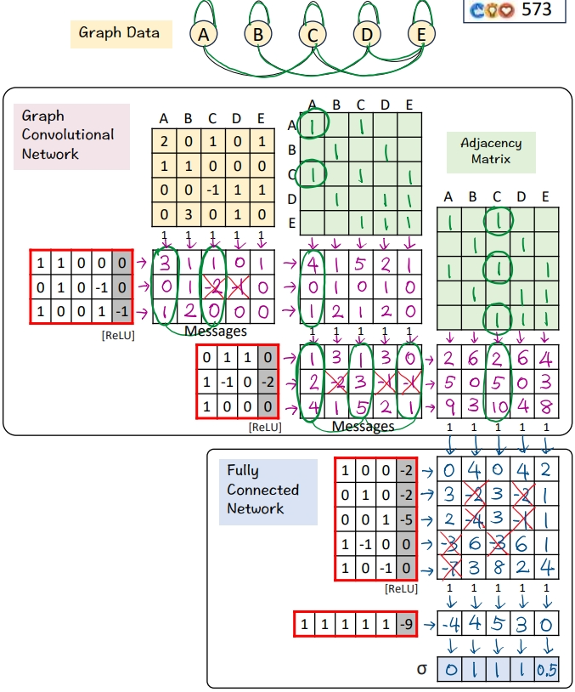

Sora's Diffusion Transformer (DiT)
- Given
- Video
- Prompt: "sora is sky"
- Diffusion step: t = 3
- Video → Patches
- Divide all pixels in all frames into 4 spacetime patches
- Visual Encoder: Pixels 🟨 → Latent 🟩
- Multiply the patches with weights and biases, followed by ReLU
- The result is a latent feature vector per patch
- The purpose is dimension reduction from 4 (2x2x1) to 2 (2x1).
- In the paper, the reduction is 196,608 (256x256x3)→ 4096 (32x32x4)
- ⬛ Add Noise
- Sample a noise according to the diffusion time step t. Typically, the larger the t, the smaller the noise.
- Add the Sampled Noise to latent features to obtain Noised Latent.
- The goal is to purposely add noise to a video and ask the model to guess what that noise is.
- This is analogous to training a language model by purposely deleting a word in a sentence and ask the model to guess what the deleted word was.
[5-7] 🟪 Conditioning by Adaptive Layer Norm

- Encode Conditions
- Encode "sora is sky" into a text embedding vector [0,1,-1].
- Encode t = 3 to as a binary vector [1,1].
- Concatenate the two vectors in to a 5D column vector.
- Estimate Scale/Shift
- Multiply the combined vector with weights and biases
- The goal is to estimate the scale [2,-1] and shift [-1,5].
- Copy the result to (X) and (+)
- Apply Scale/Sift
- Scale the noised latent by [2,-1]
- Shifted the scaled noised latent by [-1, 5]
- The result is "conditioned" noise latent.
[8-10] Transformer

- Self-Attention
- Feed the conditioned noised latent to Query-Key function to obtain a self-attention matrix
- Value is omitted for simplicity
- Attention Pooling
- Multiply the conditioned noised latent with the self-attention matrix
- The result are attention weighted features
- Pointwise Feed Forward Network
- Multiply the attention weighted features with weights and biases
- The result is the Predicted Noise
🏋️‍♂️ Train

- Calculate MSE loss gradients by taking the different between the Predicted Noise and the Sampled Noise (ground truth).
- Use the loss gradients to kick off backpropagation to update all learnable parameters (red borders)
- Note the visual encoder and decoder's parameters are frozen (blue borders)
🎨 Generate (Sample)

- Denoise
- Subtract the predicted noise from the noised latent to obtain the noise-free latent
- Visual Decoder: Latent 🟩 → Pixels 🟨
- Multiply the patches with weights and biases, followed by ReLU
- Patches → Video
- Rearrange patches into a sequence of video frames.
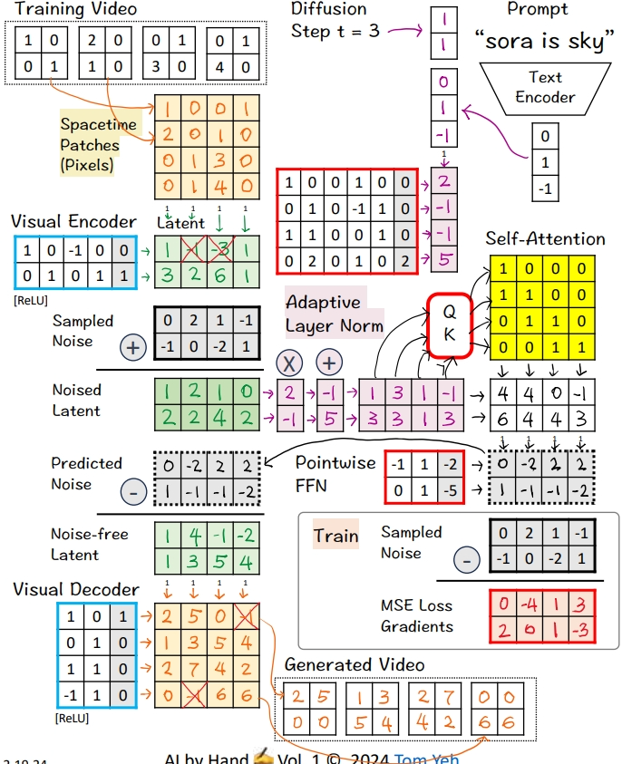

Switch Transformer
- Given
- Input features (X1-X5) from the previous block

🟨 ​🇦​​🇹​​🇹​​🇪​​🇳​​🇹​​🇮​​🇴​​🇳​

- Attention Matrix
- Feed all 5 features to a query-key attention module (QK) to obtain an attention weight matrix (A).
- Pooling
- Multiply the input features with the attention weight matrix to obtain attention weighted features (Z1-Z5).
- The effect is to combine features across positions (horizontally)
- Visualize Pooling
- Z4 := X4 + X5 because the 4th column in the attention weight matrix A is [0,0,0,1,1]

🟩 🇸​​🇼​​🇮​​🇹​​🇨​​🇭

- Gate Values
- Multiply attention weighted features (Zs) with switch matrix
- For each weighted feature Zi, each gate value indicates how well an expert (A,B,C) can probably handle the feature
- Top Expert
- Find the row (Expert ID) with the highest gate value
- "Sparse" refers to the selection of only the top expert, not all the experts.

🟦 ​🇫​​🇫​​🇳​

- Routing
- Each Z is routed to the best expert
- Each expert has a fixed capacity of 2.
- Note that Z5, which is supposed to go to Expert C, exceed's the capacity.
- Expert A: Linear Layer
- Apply the linear layer (multiply Z1 with weights and biases)
- The effect is to combine features across feature dimensions (vertically).
- Expert A: Aggregate
- Send the resulting combined feature to corresponding output column.
- The paper has an extra scaling step, omitted here for simplicity.

- Expert B
- Repeat [8] and [9]

- Expert C
- Repeat [8] and [9]
- However, since Z5 exceeded Expert C's capacity, it was simply passed through as is to the next block.
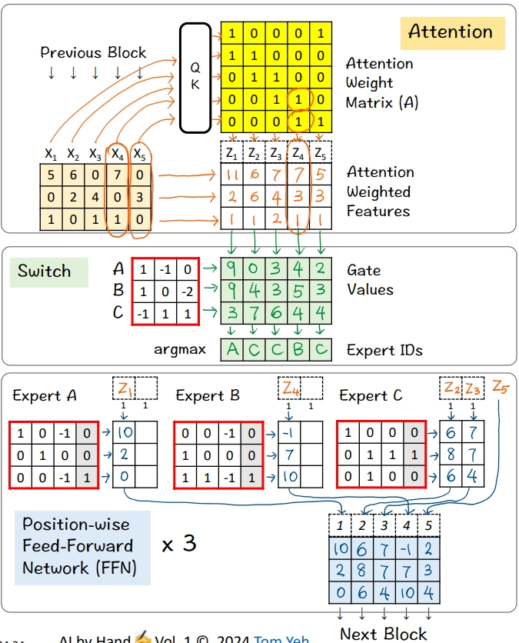

Reinforcement Learning with Human Feedback
- Given
- Reward Model (RM)
- Large Language Model (LLM)
- Two (Prompt, Next) Pairs

🟪 TRAIN RM
Goal: Learn to give higher rewards to winners

- Preferences
- A human reviews the two pairs and picks a "winner"
- (doc is, him) < (doc is, them) because the former has gender bias.

[3]-[6] Calculate the Reward for Pair 1 (Loser)

- Word Embeddings
- Lookup word embeddings as inputs to the RM
- Linear Layer
- Multiply the input vectors with RM's weights and biases (4x4 matrix)
- Output: feature vectors
- Mean Pool
- Multiply the features with the column vector [1/3,1/3,1/3] that achieves the effect of averaging the features across the three positions
- Output: sentence embedding vector
- Output Layer
- Multiply the sentence embedding with the weights and biases (1x5 matrix)
- Output: Reward = 3
- Reward for Pair 2 (Winner)
- Repeat [3]-[6]
- Output: Reward = 5
- Winner vs Loser's Reward
- Calculate the difference between the winner and the loser's reward
- RM wants this gap to be positive and as large as possible
- 5 - 3 = 2
- Loss Gradient
- Map reward gap to a probability value as prediction: σ(2) ≈ 0.9
- Calculate loss gradient by Prediction - Target: 0.9 - 1 = -0.1
- The Target is 1 because we want to maximize the reward gap.
- Run backpropagation and gradient descent to update RM's weights and biases (purple border)

🟧 ALIGN LLM
Goal: Update weights to maximize rewards


